**Chromosomes and Genes**

**Independent Practice**

1 Arrange the following structures from smallest to largest;

Gene Chromosome Nucleotide Phosphate

|  |
| --- |
| Phosphate, Nucleotide, Gene, Chromosome |

2 Circle the sex chromosomes shown in in the human karyotype below.

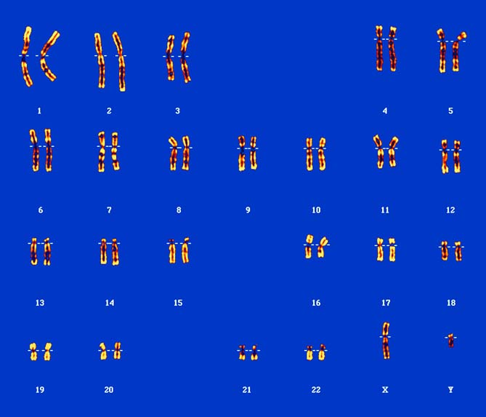

3 Is the karyotype above for a male or a female? How can you tell?

For a male, as it shows one X chromosome and one Y chromosome. If it were for a female, there would be two X chromosomes.

4 If unravelled, the DNA of a single cell would be approximately 2 metres long. Explain how it fits inside a cell.

DNA is tightly coiled around histone proteins, which are also coiled together, condensing the DNA into chromosomes that fit within a single cell.

5 A gene is a section of DNA. Explain what makes one gene different from any other gene within a DNA strand.

The nitrogen base sequence within the particular section of DNA for a gene makes it different from any other gene.